AMERICAN HERDING BREEDS ASSN.
AND

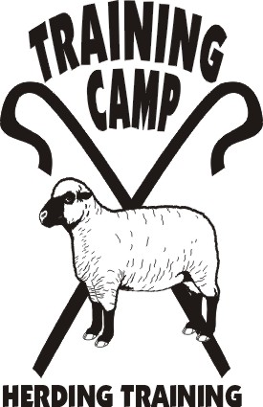

JUNIOR HERDING DOG
HERDING TRIAL DOG

HERDING TRIAL ARENA DOG
HERDING RANCH DOG - MIXED FLOCK

June 8-9, 2013

LOCATION:

Seaman Farm, Chisago, MN

OPEN TO ALL HERDING AND MIXED HERDING BREEDS
(DOGS AT LEAST 6 MONTHS OF AGE)
TEST CLASS: JHD – Sheep and Goats (Sunday)
TRIAL CLASSES: HTD I, II, II – Sheep (Saturday)
HTAD I, II, III – Ducks (Sunday)
Course 2 w/gather & shed
HTAD I, II, III – Sheep (Saturday)
Course 2 w/gather & gate sort
HRD MF I, II, III – Sheep/Ducks (Sunday)

ENTRY LIMITS: 30 – Sheep - Saturday
15 HTAD – Ducks
15 HRD - Mixed Flock
10 JHD

JUDGE: JoAnna Yund

MAIL ENTRIES TO:
Julia Torgersen
5416 – 245th St.
Forest Lake, MN 55025
jrtsplash@midco.net

ENTRY FEES:
PRE-ENTRY (Due 5/22/13) $30/first run & $25/additional runs
Day-Of (livestock available) $40/run

TRIAL CHAIR: JoAnna Yund
JoAnnaY@aol.com

- Handlers Meeting times will be sent after closing
- Competitors are responsible for cleaning up after their dogs. All dogs must be on leash when not competing.
- Competitors assume financial responsibility for medication and/or veterinary care and/or replacement value of stock for any injury caused by them or their dog(s).
- Handler’s are responsible for sending to trial secretary their AHBA recording forms

DIRECTIONS TO SITE – available at www.trainingcampinc.com

